1. Open Selenium IDE and record a test that searches for 'Bluetooth Headphones' on Flipkart, then waits for the product results to appear before clicking on the first product.
Ans=> 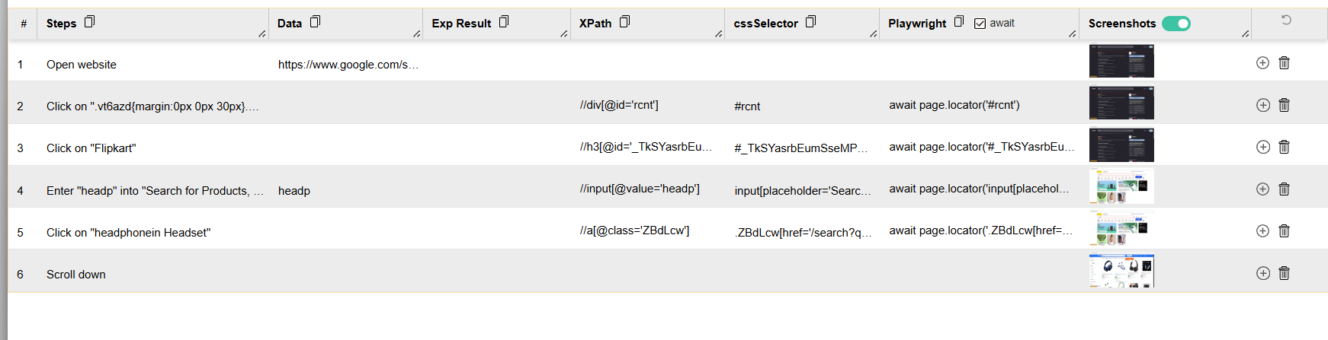

2. Add an explicit wait in your Selenium IDE test to ensure the 'Add to Cart' button is visible before clicking it on a product page, simulating a real user action on a shopping site like Myntra.<br><br><em><strong>Hint:</strong> Use the 'wait for element visible' command in Selenium IDE.</em>
Ans=>
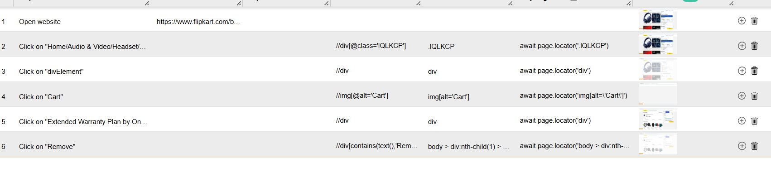

3. Simulate an AJAX wait scenario by recording a test in Selenium IDE that enters a location in the Zomato search bar and waits for the dropdown suggestions to appear before selecting one.<br><br><em><strong>Hint:</strong> Use a wait command that targets the suggestions dropdown.</em>
Ans=> 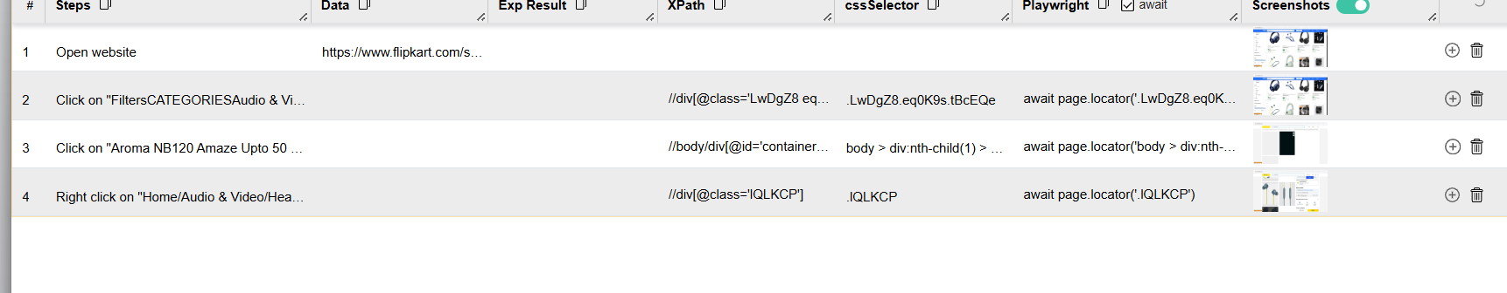

4. You have a Selenium IDE test that sometimes fails because the Instagram login button appears after a delay. Identify where to add a wait command and fix the test so it passes reliably.
Ans=> 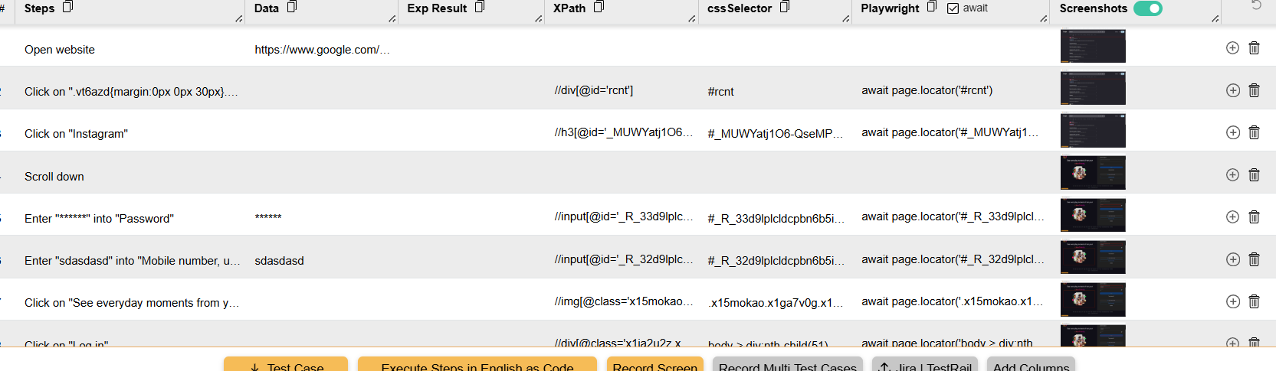

5. Explain in your own words the difference between implicit and explicit waits in Selenium, and give a real-world example for each from any app you use daily.
Ans=> Implicit wait
An implicit wait tells Selenium to keep looking for an element for a specified amount of time before giving up. It applies globally to all element searches in the WebDriver session.
from selenium import webdriver
Explicit wait
An explicit wait waits for a specific condition on a specific element. You can wait for conditions such as an element becoming clickable, visible, or present.
Implicit wait Explicit wait
Applies globally Applies to a particular condition/element
Simple to configure More precise and flexible
Waits while searching for elements Waits for a specified condition
Can make debugging timing issues harder Usually preferred for dynamic pages

